|  |  |
| --- | --- |
| Team ID | PNT2022TMID43251 |
| Project Name | Smart Waste Management System For Metropolitan Cities |

Write code and connections in wokwi for ultrasonic sensor. Whenever the distance is less than 100 cm, send "alert" to IBM cloud and display in device recent events.

WOKWI LINK: <https://wokwi.com/projects/347136221699375700>

CODE:

#include <WiFi.h> #include <PubSubClient.h> WiFiClient wifiClient; String data3;

#define ORG "x0fxss"

#define DEVICE_TYPE "Noder" #define DEVICE_ID "1234"

#define TOKEN "987654321"

#define speed 0.034

#define led 14

char server[] = ORG ".messaging.internetofthings.ibmcloud.com"; char publishTopic[] = "iot-2/evt/Kaviya_assignment4/fmt/json"; char topic[] = "iot-2/cmd/home/fmt/String";

char authMethod[] = "use-token-auth"; char token[] = TOKEN;

char clientId[] = "d:" ORG ":" DEVICE_TYPE ":" DEVICE_ID;

PubSubClient client(server, 1883, wifiClient);

const int trigpin=5; const int echopin=18; String command; String data="";

long duration; float dist; void setup()

{

**Serial**.begin(115200); pinMode(led, OUTPUT); pinMode(trigpin, OUTPUT); pinMode(echopin, INPUT); wifiConnect(); mqttConnect();

}

void loop() {

bool isNearby = dist < 100; digitalWrite(led, isNearby); publishData();

delay(500);

if (!client.loop()) { mqttConnect();

}

}

void wifiConnect() {

**Serial**.print("Connecting to "); **Serial**.print("Wifi"); WiFi.begin("Wokwi-GUEST", "", 6);

while (WiFi.status() != WL_CONNECTED) { delay(500);

**Serial**.print(".");

}

**Serial**.print("WiFi connected, IP address: "); **Serial**.println(WiFi.localIP());

}

void mqttConnect() {

if (!client.connected()) {

**Serial**.print("Reconnecting MQTT client to "); **Serial**.println(server); while (!client.connect(clientId, authMethod, token)) { **Serial**.print(".");

delay(500);

}

initManagedDevice();

**Serial**.println();

}

}

void initManagedDevice() { if (client.subscribe(topic)) {

// Serial.println(client.subscribe(topic));

**Serial**.println("IBM subscribe to cmd OK");

} else {

**Serial**.println("subscribe to cmd FAILED");

}

}

void publishData()

{

digitalWrite(trigpin,LOW); digitalWrite(trigpin,HIGH); delayMicroseconds(10); digitalWrite(trigpin,LOW); duration=pulseIn(echopin,HIGH); dist=duration*speed/2; if(dist<100){

String payload = "{\"Alert Distance\":";

payload += dist; payload += "}"; **Serial**.print("\n");

**Serial**.print("Sending payload: ");

**Serial**.println(payload);

if (client.publish(publishTopic, (char*) payload.c_str())) {

**Serial**.println("Publish OK");

}

}

if(dist>100){

String payload = "{\"Distance\":"; payload += dist;

payload += "}"; **Serial**.print("\n"); **Serial**.print("Sending payload: "); **Serial**.println(payload);

if(client.publish(publishTopic, (char*) payload.c_str())) {

**Serial**.println("Publish OK");

}else {

**Serial**.println("Publish FAILED");

}

}

}

OUTPUT:

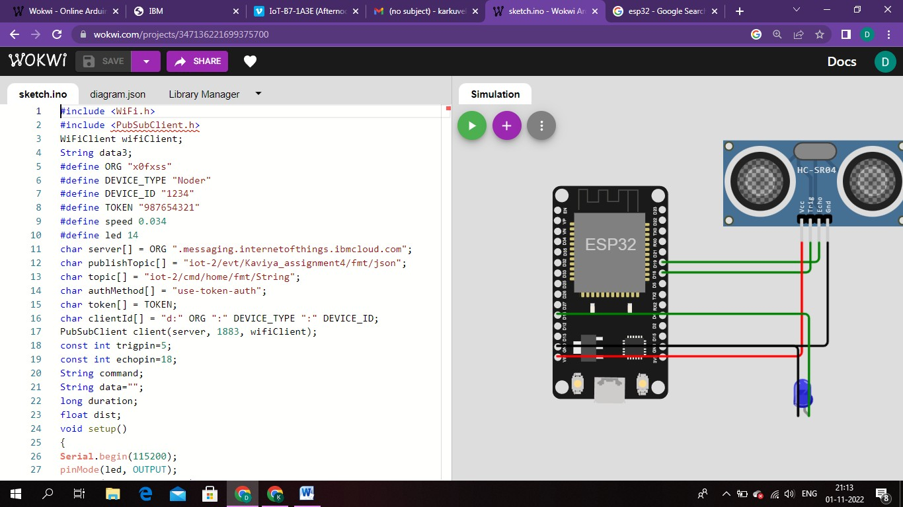

1. When distance greater than 100 ,

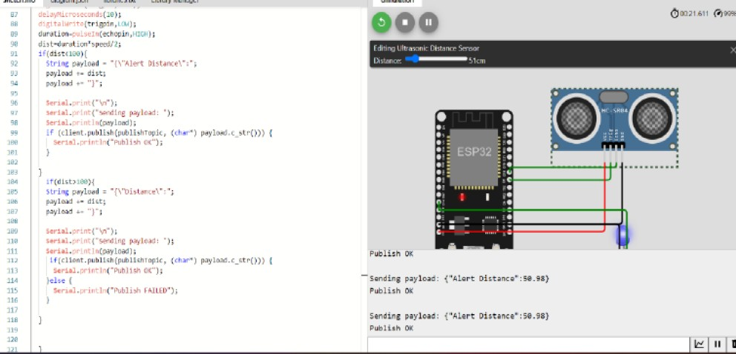

1. When distance less than 100 ,

